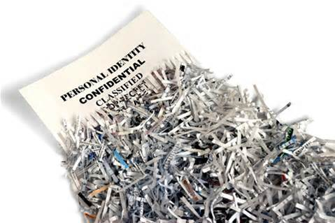

**Shredder Day**

**The shredding of documents with personal, confidential information is recommended by the State Attorney General’s office to protect us from identity theft. IntelliShred will be at Princeton Windrows to shred sensitive, personal documents at no cost.**

**Drive your materials to the mobile shredding truck in the Front Parking Lot and they will unload it. If you need assistance, please place a Work Order with our facilities staff and they will help you bring your materials to the shredder. This service is open to all residents and employees.**

\***Accepted items: paper, magazines, soft & hard cover books**

**Thursday, June 27th**

**From 8:00am - 12:00pm**

**In the Front Parking Lot**

**Provided by cid:image002.png@01CAC6BF.8B6D9BF0**